**EXPERIMENT:22**:

**Aim:** To Create a Storage service using any Public Cloud Service Provider (Azure/GCP/AWS) and check the public accessibility of the stored file to demonstrate Storage as a Service.

**Implementation:**

STEP:1:: open azure and create account Go to resource groups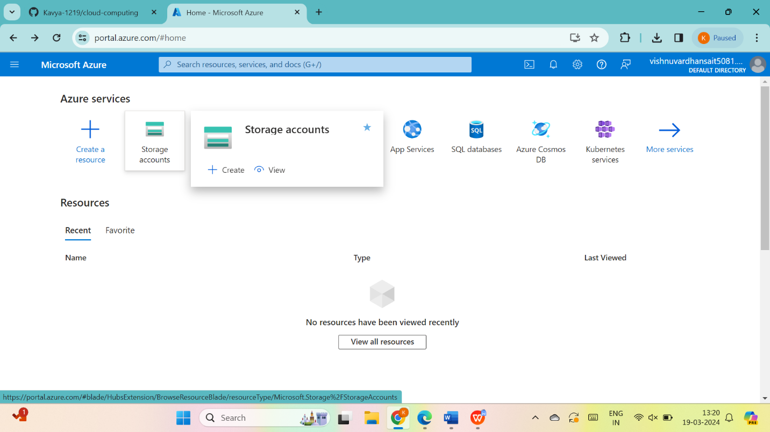THEN GO THE CREATE THEN 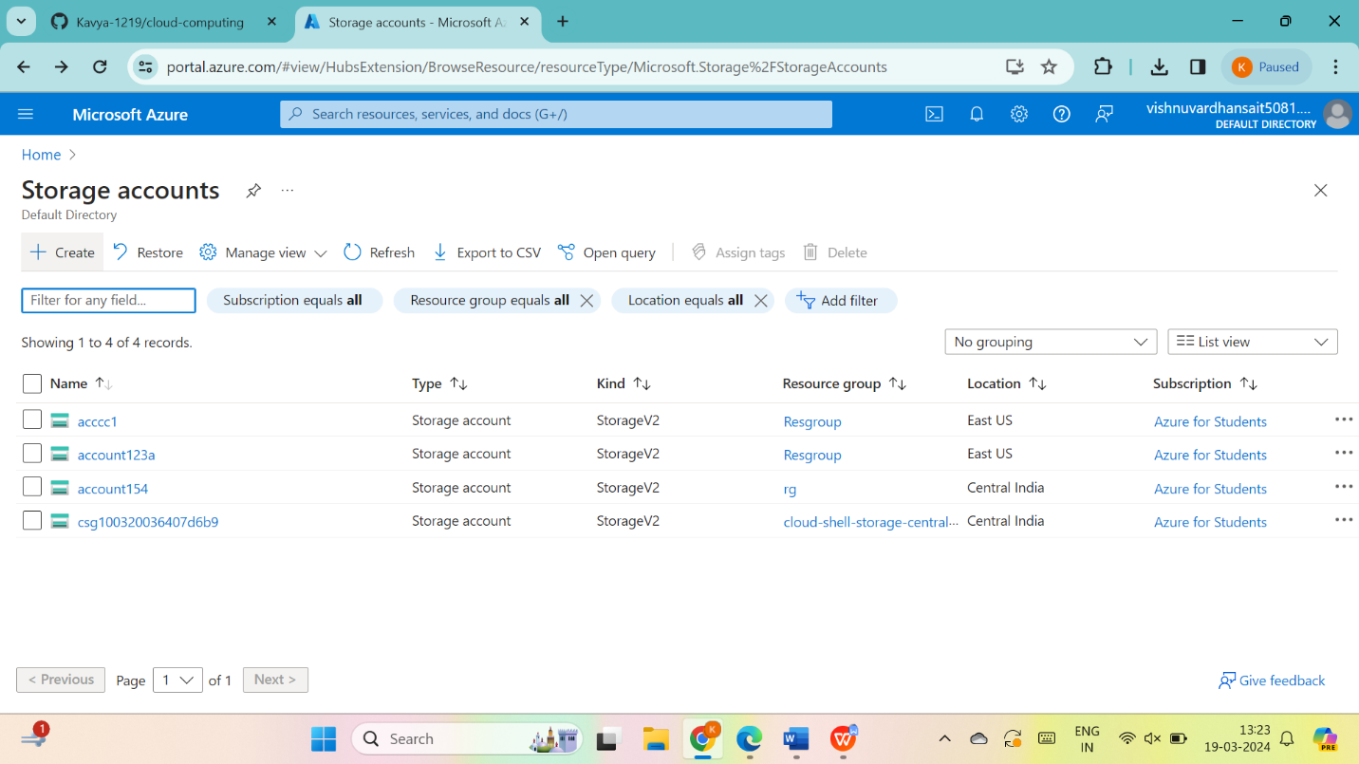

Assign name to storage account and give next

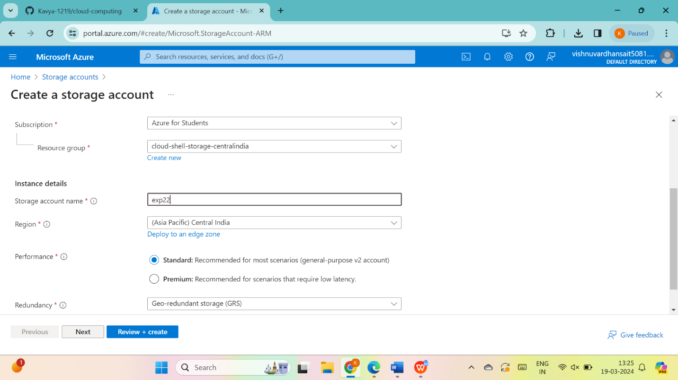

give next for advanced

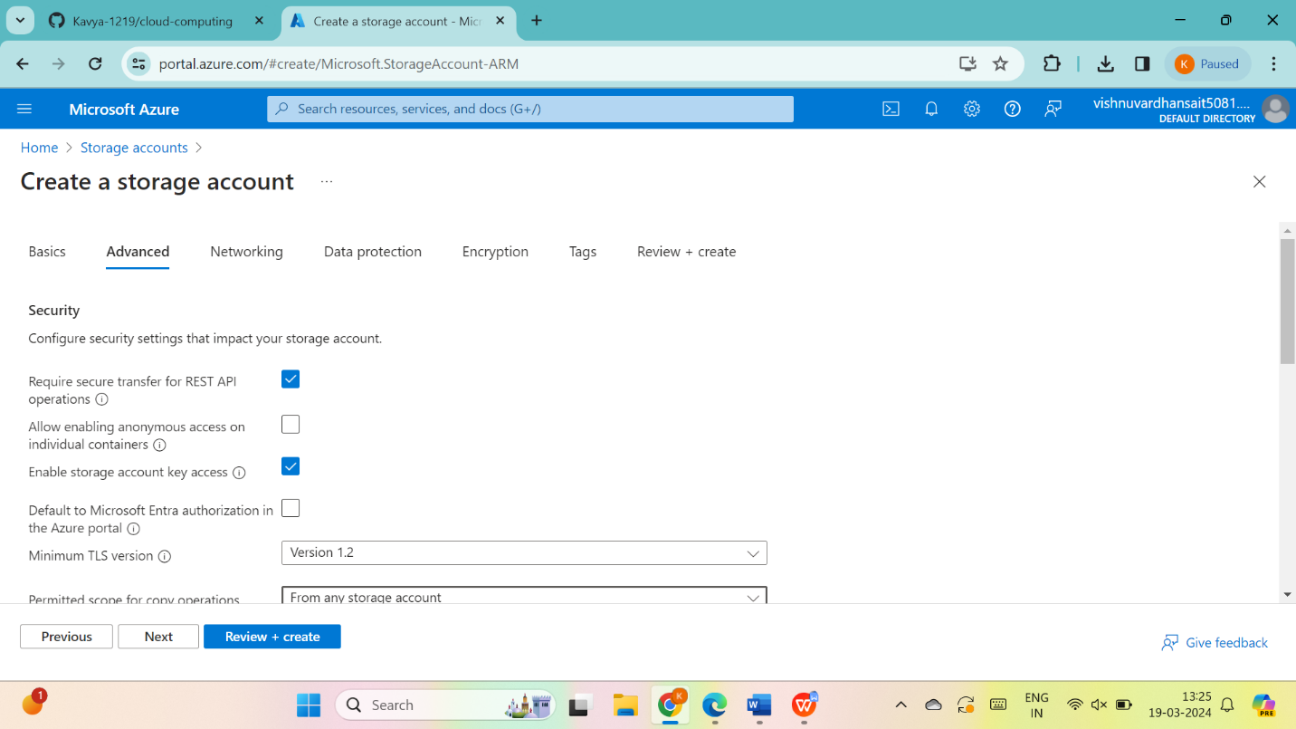

give next for networking

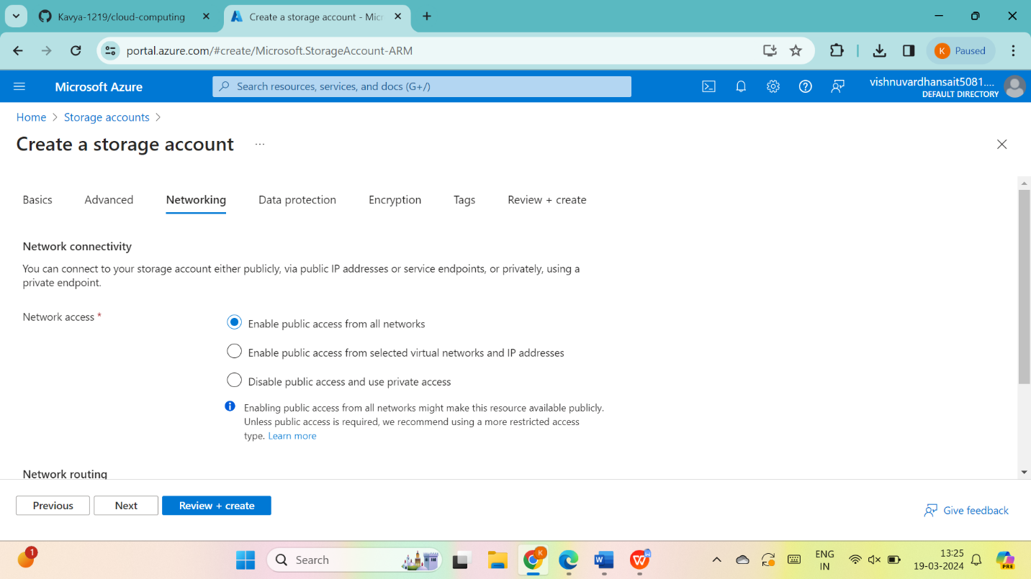

give next for data protection

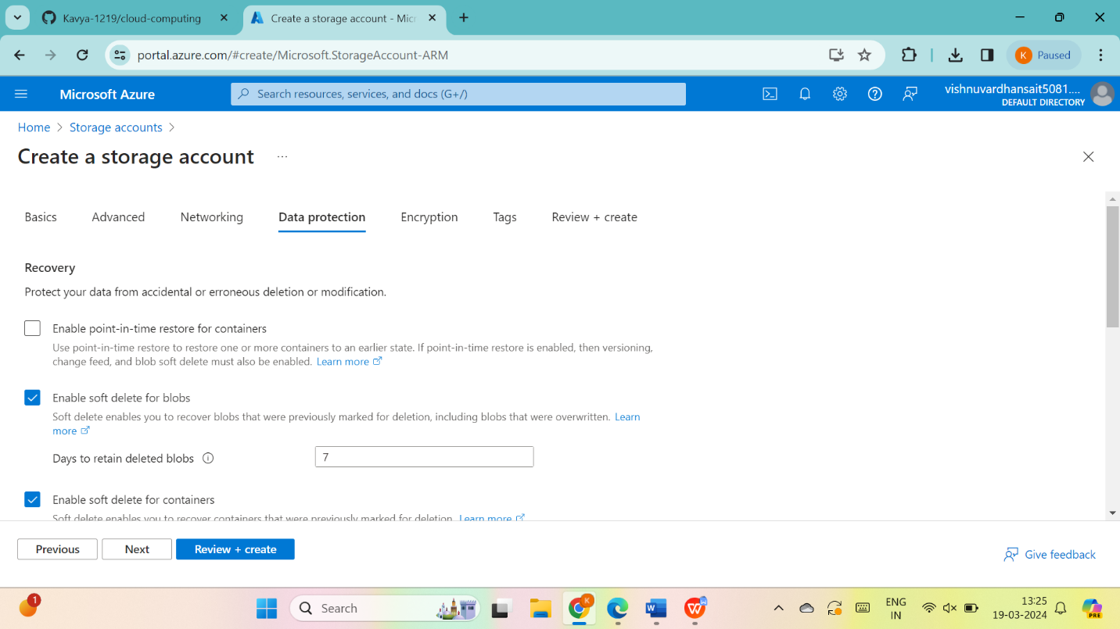

give next for encryption

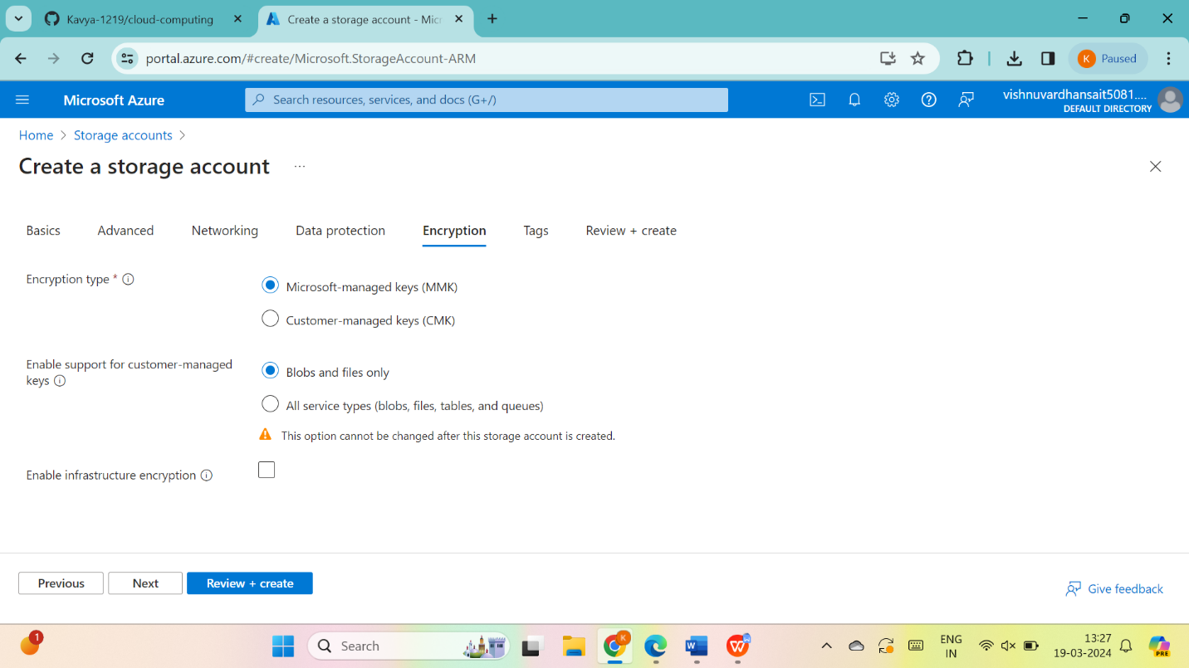

give next for tags

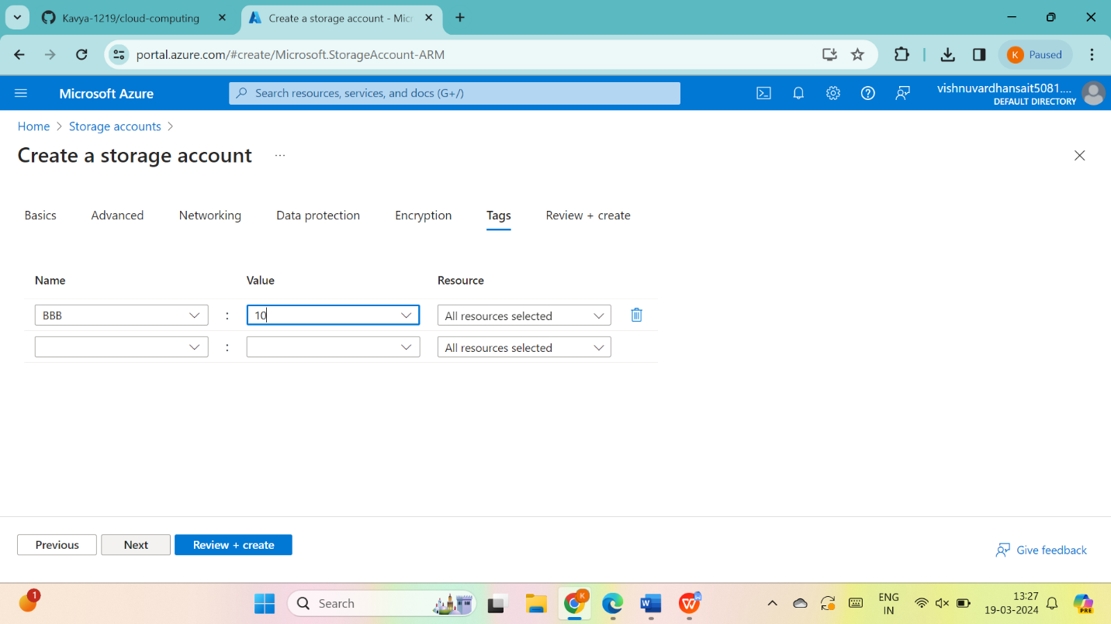

give next for review + create and go to create

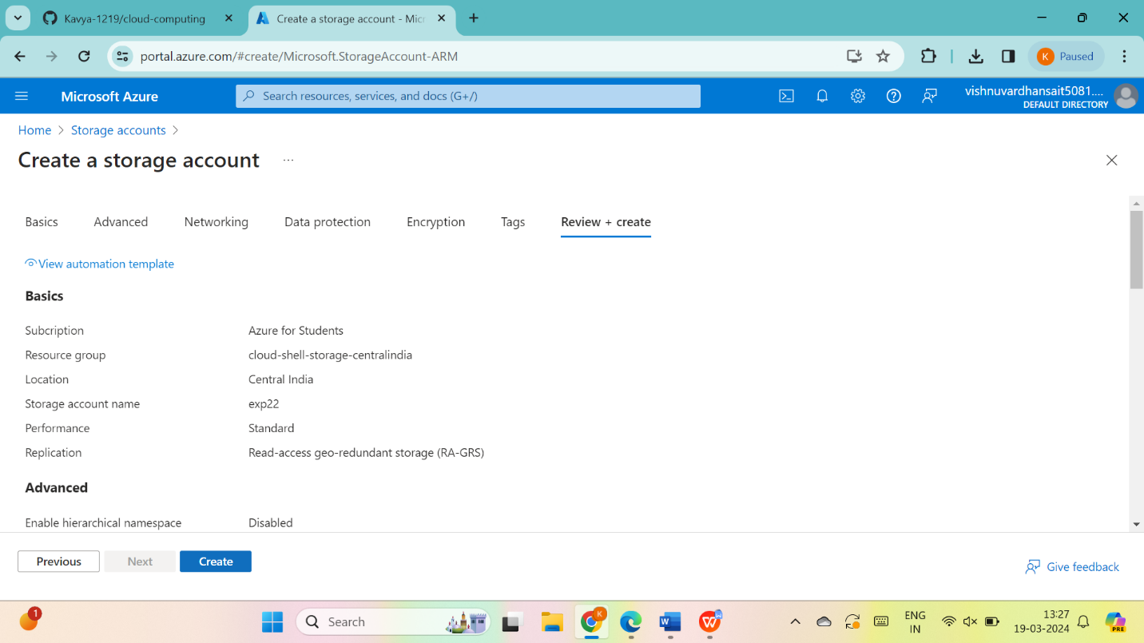

Now the deployment is completed

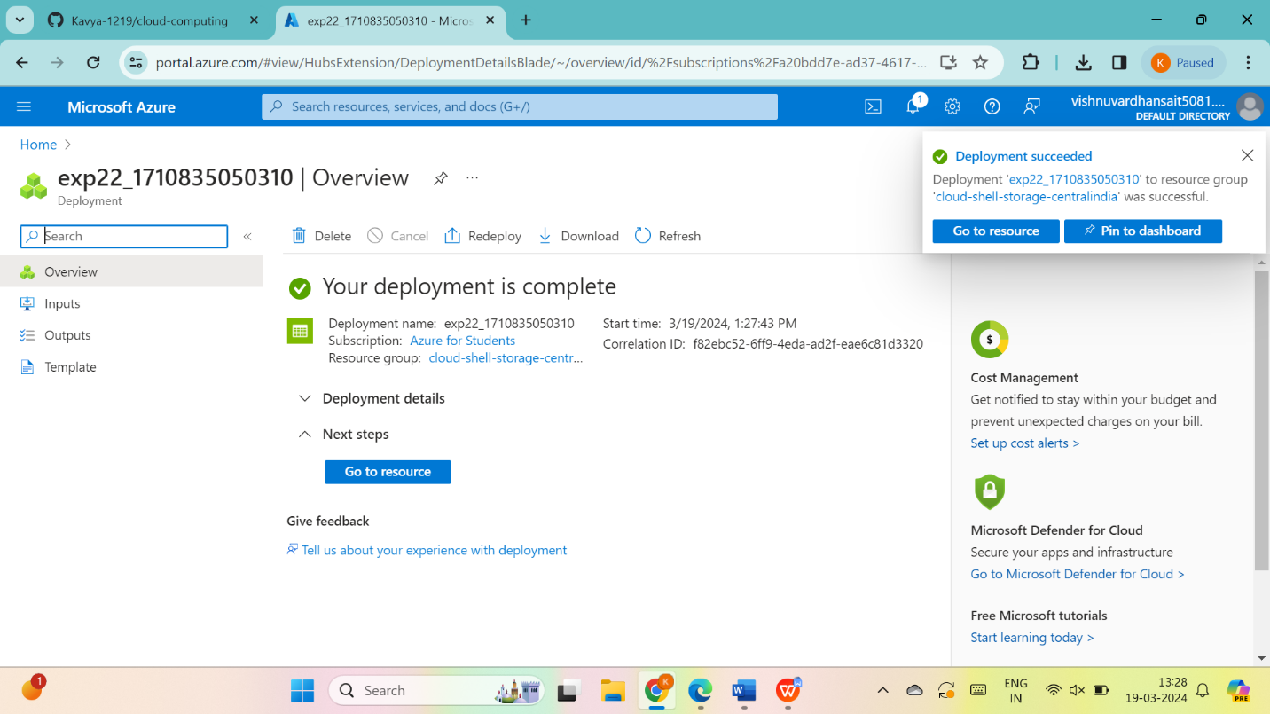

Go to storage browser >file shares and add file

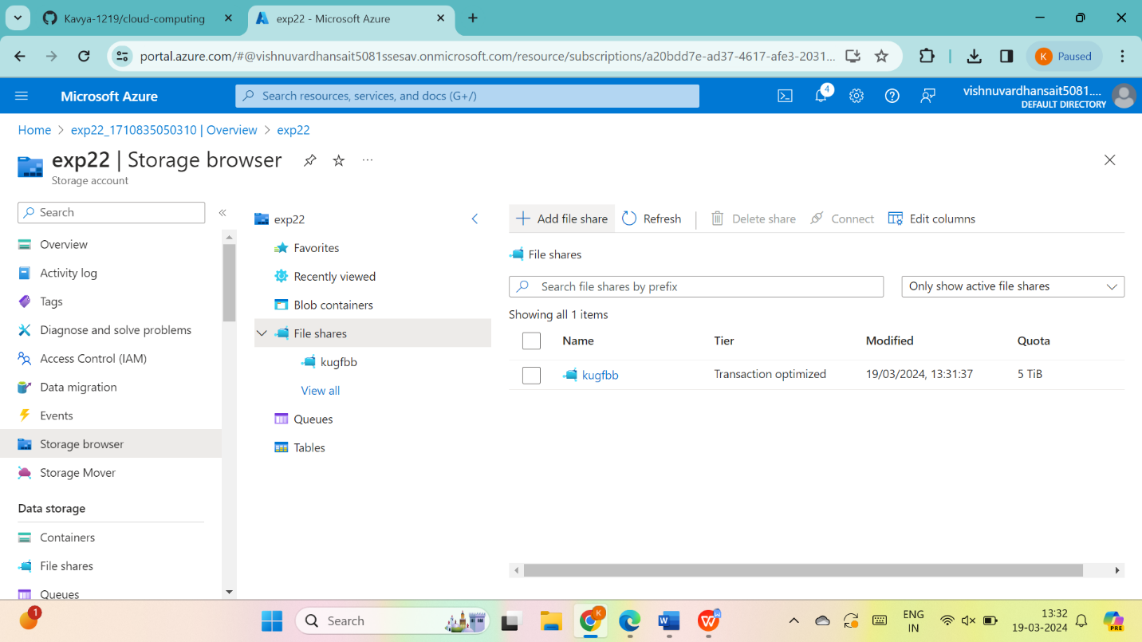

Upload any file into it

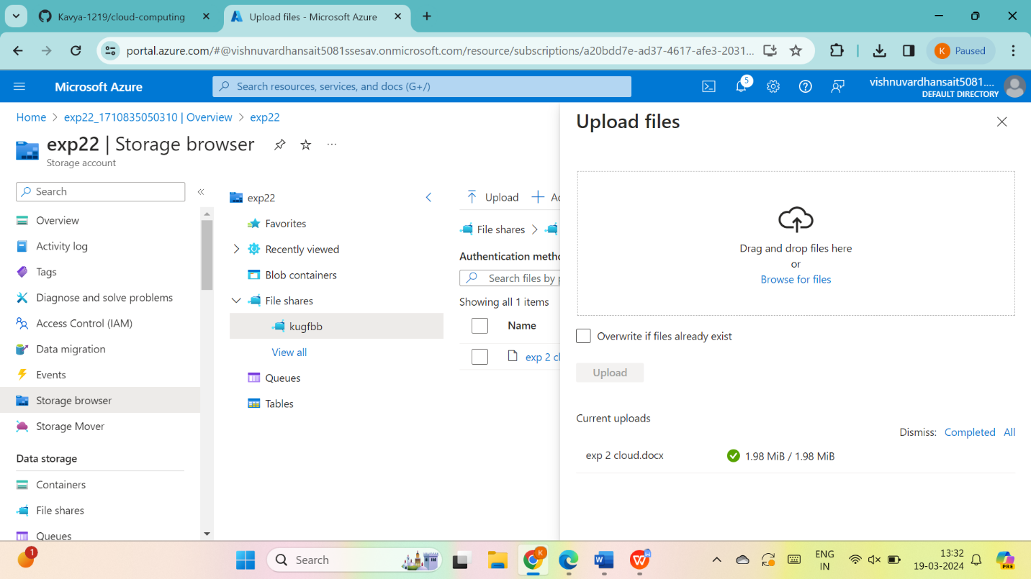

RESULT : THUS ,THE PROGRAM HAS BEEN EXCEUTED SUCCESSFULLY.

